To Be Honest…

#1
Today's Learning Material:
Our forefather Yaakov is known as being the pillar of truth, as it states in the Book of Michah: “Give truth to Yaakov."

According to Kabbalistic teachings, Yaakov also embodies the concept of beauty.

Question: What is the commonality between truth and beauty?

#3
Pirkei Avos 1:18
The world is sustained by three things: justice, truth and peace.

Questions:
- How do you understand this statement?
- If your actions were certain to remain secret, would your level of honesty be different than if you were afraid of getting caught?
- How do you react when someone is dishonest with you?

#4
She’iltos 36
Rav Safra was once reciting the Shema when a nobleman made an offer to purchase an item. Misinterpreting Rav Safra’s silence, the buyer increased his offer. When Rav Safra finished his prayers, he insisted on accepting the initial lower offer – having mentally accepted it when it was made.

Questions:
- In which situations have you been honest even though it was very difficult for you?
- What do you think about the following attitude - "I cannot tell a lie or distort the truth when I say something, no matter what the consequences"?

#5
Question: How do you define Truth/ Falsehood?
Merriam Webster dictionary
Definition of Truth
The body of real things, events, and facts

Definition of Falsehood
Absence of truth or accuracy

Michtav M’Eliyahu, Vol. I, p. 94
Truth is that which brings good and accords with the Will of G-d, and falsehood is that which is the opposite.

Questions:
- How do you understand Rabbi Dessler's definition?
- What are some practical examples of this?
- How does it differ from the common definition?
- Does this mean the “the end justifies the means” and we can lie to bring about a necessary result?

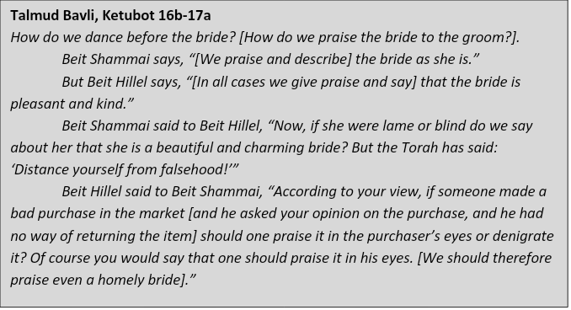
#6

Questions:
- How do you understand the disagreement between the schools of Hillel and Shamai?
- In what situations do you consider it is appropriate to distort the truth?
- If you wanted two people to get married to each other, would you leave out negative information about one party?

#7
G-d Himself taught us that it is permissible to lie for the sake of peace in the home, to preserve and promote the affection in a marriage:
When He told Sarah that she was going to have a child, she laughed and said, “I am old and my husband is old.” Upon repeating the story to Avraham, G-d omitted the part about her husband being old –- even though he was 99 at the time!

Question: In which situations would you sanction being dishonest in order to avoid confrontation?

#8
Kabbalah
This world is a world of illusion.

Question: Would you consider social media as a place of lies and illusions? Explain!

#9
Torah Shemos 23:7
Distance yourself from falsehood.

Question: What would motivate people to become more honest than they are?

#10
Question: What's your takeaway from today's discussion?

